Reid Collins

This document explains how to operate the vacuum chamber and vacuum pump along with testing procedures for everything related to vacuum

Vacuum Testing

Revision: 1.0.0



Table of Contents

1 Vacuum Chamber and Pump Specifications 2

1.1 Vacuum Chamber Specifications 2

1.2 Vacuum Pump Specifications 2

2 Operating the Vacuum Chamber 3

3 Testing Procedures 6

3.1 Thermal Vacuum Test 6

3.2 Absolute Vacuum Test 6

# Vacuum Chamber and Pump Specifications

This section will summarize the specifications for both the vacuum chamber and the vacuum pump. Read and understand these before attempting to operate the vacuum pump.

## Vacuum Chamber Specifications

The vacuum chamber that will be used by Cougs in Space is a Sanatron LLC chamber with a $10”$ inside diameter in every dimension. The chamber is made from acrylic and epoxy, these materials are very sensitive so ensure that you **DO NOT EXPOSE THE CHAMBER TO SOLVENTS** (i.e. Alcohol, Acetone, etc.). To clean the chamber only use soap and water.

This chamber is **rated down to $0.075 Torr$ pressure**, do not go lower than this pressure. There is a digital pressure sensor mounted to the top of the chamber which reads down to $0.001 Torr$. Under atmospheric conditions the pressure sensor should read approximately $760 Torr$. The chamber so far has been tested down to approximately $0.480 Torr$. The leakage rate of this chamber is rated at no less than $5.25 Torr/24 hours$. This chamber is **rated for temperatures between $-110 °C$ and $41 °C$** .

The top of the chamber contains four clamps which must be tightened down to the lid before operating the chamber. There are two valves on the top of the chamber, one for opening/closing the connection between the chamber and the pump, and another valve for venting to the atmosphere once testing has been completed. Each valve is open when the yellow handle points up (perpendicular to the floor of the chamber) and closed when the handle is parallel to the floor of the chamber.

This vacuum chamber does not have any openings in it for electrical connections so in order **to supply power, batteries will need to be used within the chamber** and **sensor measurements will need to be transmitted wirelessly.**

## Vacuum Pump Specifications

The vacuum pump that we currently possess is a $2.5 CFM$ (cubic feet per minute) vacuum pump made by Pittsburgh Automotive. This **pump is rated for a vacuum of $75 microns$.** The pump requires approximately $8.5 ounces$ of **HFV-46 low-viscosity vacuum pump oil.** This oil can be added by opening the oil fill plug cap and pouring oil into the chamber until the level of the oil sight glass is up to the line shown on the front of the pump.

# Operating the Vacuum Chamber

Follow these steps to run the vacuum chamber:

1. Put on safety glasses.
2. Insert the part that you want to test into the vacuum chamber.
3. Place the top of the chamber squarely on top of the base of the chamber.
4. Tighten the top of the chamber down by applying each of the clamps found in the corners of the base (The clamps have red bases).
5. Plug the pressure sensor found on the top of the chamber into a wall outlet.
6. Connect the vacuum hose found with the chamber to the nozzle on the top of the chamber (to the right of the pressure gauge when the gauge is facing forwards). Tighten the hose with the clamp surrounding the hose using a screwdriver to fasten the hose to the nozzle. See Figure 1 below:

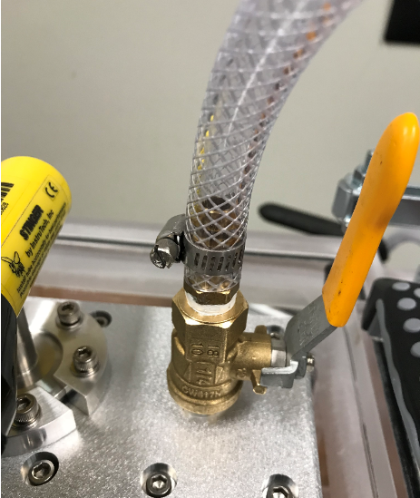

Figure 1: Hose Attachment to the Vacuum Chamber

1. Attach the other end of the hose to the nozzle on the top of the vacuum pump using a similar method to step 6. See Figure 2 below:

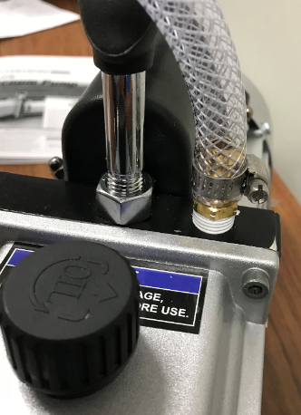

Figure 2: Hose Attachment to the Vacuum Pump

1. Check the sight-glass on the front of the vacuum pump and ensure that the level of the oil is at or above the line on the front of the pump. Make sure that you check this on a level surface. If the level of the oil is too low, add more oil (see specifications for the type of oil) by unscrewing the cap found directly above the oil chamber and pour oil in until the level surpasses the line. Screw the cap back on when you have finished adding oil. See Figure 3 below:

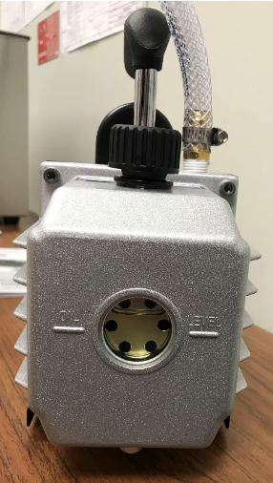

Figure 3: Oil Level of the Vacuum Pump

1. Open the valve on the vacuum chamber that is attached to the hose (the right-most valve) by pulling up on the yellow handle so that the handle points upwards.
2. Close the venting valve (the left-most valve) by pulling down on the yellow handle until it is parallel to the ground. See Figure 4 below for how the chamber should look while running:

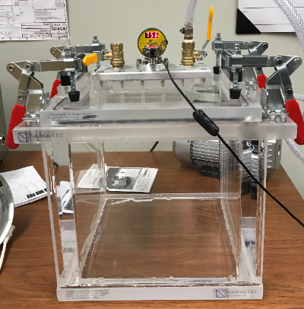

Figure 4: Vacuum Chamber Setup for Operation

1. Before turning on the vacuum pump, ensure that the area is well-ventilated because some vapor will vent out of the pump when it is switched on.
2. Turn on the vacuum pump by flipping the switch found on the back of the pump (opposite side to the oil sight-glass). Switch on a timer and run the pump for $10 minutes$ (this will get most of the way to vacuum). See Figure 5 below:

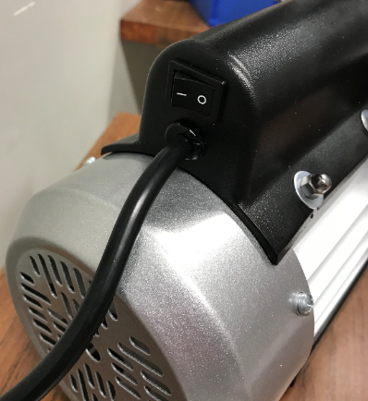

Figure 5: Vacuum Pump ON Switch

1. The vacuum pump will get hot with extended operation so be sure to not touch any metal portion of the pump.
2. Monitor the pressure gauge (it will start in Torr and once it gets under $1 Torr$ the gauge switches to millitorr ($0.001 Torr$).
3. Once the desired vacuum is reached, close the valve connected to the hose, then switch off the vacuum pump. Closing the valve first helps to maintain the vacuum in the chamber and keeps the chamber from sucking oil out of the pump.
4. While running your tests you may want to keep the pump running to maintain the level of vacuum.
5. Once your tests are finished, de-pressurize the chamber by slowly opening the valve on the left of the chamber (opposite to the hose side). This will cause suction so ensure that nothing is on top of the valve when it is opened. See Figure 6 below for the proper venting (de-pressurizing) setup:

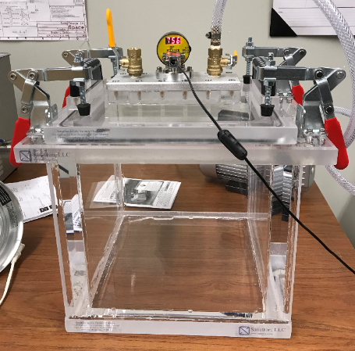

Figure 6: Vacuum Chamber Setup for Venting

1. Once the pressure gauge reads approximately $760 Torr$ again, open the vacuum chamber by removing the four red-handled clamps.
2. Unplug the vacuum pump and let it sit for at least an hour before performing any other tests with it since the pump gets hot during operation.

# Testing Procedures

These procedures will be updated at a later date.

## Thermal Vacuum Test

## Absolute Vacuum Test